- FINALS TIME  FALL 2021  In this issue, we will cover the following topics:  - Alternative Testing  - Success Coaches  - FAFSA Renewal  - Winter/Spring 2022 Reminders  - Fun Lessons!  - Contact Us  Los Angeles City College  855 N. Vermont Avenue  Los Angeles, CA 90029  Office of Special Services  Student Services Bldg., 1st fl.  Phone: (323) 953-4000 ext. 2270 (TTY/TDD)  Email: oss@lacitycollege.edu  Cranium Café: https://tinyurl.com/w7zhpu75  Website: https://tinyurl.com/2xfekjbx | OSS Student Newsletter  Volume 1, Issue 3  Hi students, it’s Finals Time! We understand how stressful and challenging this time of semester may be, and we want to remind you of the various supports in OSS that can be of assistance and help to you during this important time! Read more below to see what’s available to you.  ALTERNATIVE TESTING SERVICES  Finals are soon approaching! Have you scheduled your appointment?  Friendly reminder that Finals are from Monday Dec 13th to Friday Dec 17th. We strongly encourage you to book with us as early as possible for finals. Please email booking requests to ossexams@lacitycollege.edu with the following information:  - Student ID:  - Class:  - Professor:  - Amount of time given in class for exam:  - Date/Time requested for exam  SUCCESS COACHES AND STUDY TIPS!  Our Success Coaches are (master-level) students from a wide range of higher ed institutions, who are here to support you and provide you with tools necessary to be successful in your classes!  Jacqueline Alcala  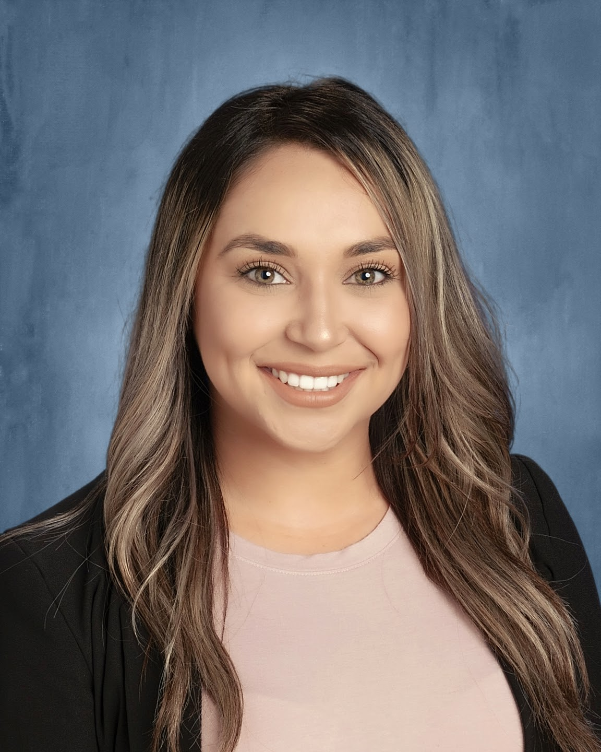  Hi, my name is Jacqueline Alcala! I completed my undergraduate studies at UC Santa Barbara, and I am now a counseling graduate student at CSU Long Beach. Being a first-generation student, I am drawn to work with historically underrepresented populations in an effort to further the educational pipeline. As one of the counseling interns at the Office of Special Services, I am looking forward to assisting all of our students as they prepare for the next chapter of their educational journey after LACC.  Success Tip: Take full advantage of the resources made available to you throughout campus. We are all here to support you and see you shine!  Claudia Rosales  Hi, my name is Claudia Rosales! I am an Educational Counseling graduate student at the University of Southern California (USC). I am one of the counseling interns in the Office of Special Services and I am very excited to be part of the team! This is my first semester working here and I’m looking forward to being able to assist everyone through their educational journey here at LACC. One thing that I’d like to share about myself is that I love to enjoy a cup of coffee while watching my favorite TV show.  Success Tip: Don't overthink or be shy to ask for help when you do not understand a concept or lesson in class. There are supports on campus to help you be successful in your classes and the Office of Special Services is definitely here to assist you! Please come visit our office when you need support or have any questions. We are here to help!  Isabel Martinez  Hi, my name is Isabel Martinez! I am very excited to be assisting as a success coach in the Office of Special Services. Currently, I am working towards earning my master’s degree in General Counseling Psychology at Mount Saint Mary’s University. I earned my BA in Political Science at University of California Riverside. I enjoy connecting with students and supporting them through the various experiences that are encountered in college. My favorite hobbies include hiking and Sunday naps.  Success Tip: According to research, organization is positively correlated with success. If you would like to get some ideas on how to organize your personal schedule, stop by OSS and we can work with you individually on creating a system that works for you. Being organized can result in more positive academic outcome and wellness!  DID YOU RENEW YOUR FAFSA FOR 2022-2023 ACADEMIC YEAR?  The application for the 2022-2023 academic year is available since October 1, 2021 and until June 30, 2023. Make sure to submit your FAFSA or DREAM Application and complete the financial aid process as soon as it is available - check the "To do list" on your Student Portal for updates to ensure that your financial aid process is completed.  If you have any questions, please visit the Financial Aid Office located in the Student Services Building, 1st floor. You can also email or call them at: finaid@lacitycollege.edu or 1 (888) 930-5222.  WINTER AND SPRING 2022 REMINDERS  - Winter term begins January 4th and ends on February 6th.  - Spring semester begins February 7th and ends on June 6th.  Priority registration for Spring enrollment begins Monday, November 22nd! If you need help planning your classes, make sure to reach out to your counselor:  Last names A-L, see Robert Dominick: DOMINIRT@LACCD.EDU  Last names M-Z, see Houa Lee: LEEH7@LACCD.EDU  FUN LESSONS! (FEATURING DEAF/HARD-OF-HEARING)  Here are some helpful tips when encountering a Deaf person.  Deaf Etiquette  1. Ask before offering help.  2. Ask for the Deaf person’s preferred method of communication.  3. Maintain eye contact.  How to Sign: THANK YOU!  Good luck on your Finals! You CAN do this!

