

**Language Academy**

**Orientation Packet**



**Welcome to Los Angele City College Language Academy!**

Every semester over 100 new international students, arrive on our campus to begin a new year at a new school, in a new country. The International staff is here to help you with your American education and to provide you with guidelines, resources, and assistance to make this a wonderful experience. The Language Academy staff and instructors look forward to seeing you in class and providing you with an excellent education. In this Orientation guide, you will find information on classes, health insurance, safety tips, American customs, on-line resources, and other services to make your first semester at LACC easy and fun!



**Placement Instructions for International Students Arriving at LACC**

1. Once you arrive to the United States, please report to the Language Academy office located in the Cesar Chavez Building, room 109 to check in.
2. Your English placement test will take place during your orientation.
3. During Orientation, all students will take a speaking/writing placement assessment with the Language Academy instructors.
4. Your level assignment will be given to you at Orientation.
5. After the campus tour – LACC students may receive their (student) picture identification card. Students may also receive this card during the first week of school the LACC staff will take students (in small groups) to the Welcome Center for their ID cards.



**General Information – Spring Session I**

**LACC Instructors**:  
Ms. Alla Bokhman Ms. Haira Chang Ms. Kenya Ganda Ms. Michelle O’Hair Mr. Joshua Steward

**Class Schedule - Fall**   
 Monday – Friday: 11am to 3pm

Class Location – Da Vinci Hall, Room 301/302

**Tuition:**

New F-1 visa students studying 20 hours a week will pay $1,200 per session. Tuition is due by the end of the first week of class. For other visas or part time students, tuition varies.

**LACC Program Dates: Session I**

* Tuesday, February 15th Orientation
* Tuesday, February 22nd Classes Begin
* Thursday, February 25th Welcome Event @ 5pm
* Saturday, March 19th Hollywood Tour
* Monday, March 28th – March 30th Testing
* Monday, April 18th Session II Start Date
* Tuesday, May 24th ISP Orientation (transferring students only)

**No Classes – Campus Closed**

* **Presidents Day:** Monday, February 21st
* **Cesar Chavez Day:** Thursday, March 31st
* **Spring Break:** Friday, April 1st.

**Location of LACC Office**

The LACC office is located in the International Student Program office, room Cesar Chavez, Admin Services: 1st Floor, room 109. 855 N. Heliotrope Avenue, Los Angeles, CA 90029. The ISP office hours are from 9am-4:00pm Monday-Thursday and Fridays 9am – 12pm.

**Emergencies**

If you or your family cannot reach the LACC office, call Campus Police for immediate assistance. You can reach them at (323)953-2911 or for emergencies, call 9-1-1.

Students: Please give your family the Campus Police phone number in case of emergencies

**Frequently Asked Questions**

|  |  |
| --- | --- |
| **If you are wondering…** | **You will contact/visit…** |
| Who do I call when I can’t go to class? I changed my address/phone number, who do I tell? I need to see a doctor, where do I go? I have problems with my housing situation – where should I go? | LACC Office  Tel: (323) 953-4000 ext. 2471 ISS Department Email: la@lacitycollege.edu Email: gagoian@lacitycollege.edu |
| Who do I talk to about my classes or level? How do I pay the tuition fee? I’m having problems with host family or friends? I’m having financial problems? | LACC Office  Tel: (323) 953-4000 ext. 2471 ISS Department Email: la@lacitycollege.edu Email: gagoian@lacitycollege.edu |
| I want to know about majors or classes at LACC?  How do I transfer to a 4-year university? | LACC International Student Counselor Keika Stevenson: [stevenk@lacitycollege.edu](mailto:stevenk@lacitycollege.edu)  You may also make an appointment with her at the LACC office. Office hours vary during summer. Tel: 323-953-4000 ext. 2473 or 2215 |
| Where do I get my LACC Student ID Card | Not Eligible for ID Card |
| How do I use the Library? | Students will be given a Library tour |
| Emergencies | LACC – Sheriff’s Office  Tel: (323) 953-2911 |
| How do I transfer to another school? | 1. Notify LACC of your intent to transfer 2. Apply to another school 3. Complete transfer-out form 4. Submit transfer-out form and acceptance letter to LACC |
| How do I travel outside of the U.S. on my F-1 Visa? | You will need to have a DSO sign your I-20 every 4 months. The travel signatures expire! |
| How do I get health insurance? | Ask LACC for more information. Students are **not** covered with their LACC tuition. |
| If I am sick, where do I go? | Urgent care if you need a doctor – do not go to the hospital unless it is an emergency. |

**Safety 101**

**ON CAMPUS:**

* Be aware of your surroundings and use caution when walking through the campus at night.
* Know the location of the emergency phones (blue poles).
* Keep personal belongings in view while in class or in the library – check your chair before leaving class.
* Try not to be busy with text messaging or cell phone use – stay aware and alert of traffic.
* If you see someone in trouble on campus – go to the emergency blue pole or the nearest campus office.
* At night, call Campus Police (323)953-4005 for Escort/Shuttle service to your car.
* Riding a skateboard on campus is forbidden.
* Using a Razor Scooter on campus is forbidden.
* Roller skating or Rollerblading is forbidden on campus.

**USING ATM MACHINES:**

1. Use the ATM machines on campus or at your bank – avoid using ATM machines at night.
2. If you feel threatened – cancel your transaction and walk away from the ATM machine.
3. Use ATM machines that are inside buildings or in well-lighted areas.

**USING A BICYCLE:**

1. Make sure your bike is in good working condition – check your brakes, belts, and frame.
2. Use reflectors or reflective tape on your bike.
3. Keep to the right . . . ride with the traffic or on the side walk if traffic is heavy and there is no bike lane AND use clearly visible bicycle paths whenever possible.
4. Use hand signals to indicate turning or stopping and walk your bike across busy intersections.
5. Park your bike in an open, well-lighted, frequently traveled area and use the U bolt locks.
6. **DO NOT RIDE YOUR BICYLE ON CAMPUS – YOU COULD GET A TICKET.**

**USING PUBLIC TRANSPORTATION**:

1. Check bus schedules and become familiar with routes and timetables for your area.
2. Wait for buses at well-lighted stops. If possible, wait with other people at a bus stop.
3. If someone bothers you on the bus, move immediately to the front and tell the driver.
4. If you are alone – stay awake on public transportation.
5. If you feel someone is following you, walk towards a populated area, a store, etc.

**USING A METRO BUS:**

Overview:

* + Metro’s fleet offers different types of services:
  + **Local buses** stop around every two blocks and are painted orange
  + **Rapid buses** are faster buses with fewer stops only at major intersections and are painted red
  + **Express buses** travel on routes on freeways for longer distances with fewer stops and has a higher premium.
  + [G Line (Orange)](https://www.metro.net/riding/g-line/)and [J Line (Silver)](https://www.metro.net/riding/j-line/) Lines are bus rapid transit lines (BRT) that run on dedicated busways and require payment by TAP card.

Riding a Metro Bus

1. Catch the bus

* + - Arrive 10 minutes early and wait away from the curb but somewhere where the operator can see you.
    - As bus approaches, wave for it to stop
    - check the head sign above windshield for route number and destination to ensure its your bus

2. Boarding the bus

* Wait for bus to make a complete stop
* Have your money or TAP card ready
* Take a seat or use handrails/handholds

3. Enjoy the Ride

4. Exiting the Bus

* Watch and listen for your stop.
* About one block before your destination, press the STOP button or pull the yellow cord
* Exit through the rear door and make sure you have all your belongings.

Riding Tips & Safety

* Never run after or next to a moving bus.
* Watch for oncoming buses in both directions.
* Let riders in wheelchairs or with disabilities board and or exit first.
* Be ready to exit when you arrive at your stops.
* Step away from bus after exiting.
* If riding with a bike, make sure you let the Operator know you will be taking your bike from the front rack.
* Use our Trip Planner in advance to plan your trip.

**USING A METRO RAIL:**

Metro rail refers to the [A](https://www.metro.net/riding/a-line/), [B](https://www.metro.net/riding/b-line/), [C](https://www.metro.net/riding/metro-c-line-green/), [D](https://www.metro.net/riding/d-line/), [E](https://www.metro.net/riding/e-line/) and [L](https://www.metro.net/riding/l-line/) Lines (Blue, Red, Green, Purple, Expo and Gold) . There is a total of 93 stations in the system, each offering connections to Metro bus. Payment of fare requires a TAP card. Regular [fare](https://www.metro.net/riding/fares/) is $1.75 and is good for 2 hrs of unlimited transfers in one direction.

### [Metro A Line (Blue)](https://www.metro.net/riding/guide/a-line/)

The recently renovated A Line (Blue) provides rail service between Downtown Los Angeles (7th St/Metro Center station) and Downtown Long Beach.

### [Metro B Line (Red)](https://www.metro.net/riding/guide/b-line/)

The B Line (Red), Metro’s 1st subway line to be built, runs between Downtown Los Angeles and North Hollywood.

### [Metro C Line (Green)](https://www.metro.net/riding/guide/c-line/)

The C Line (Green) runs between Redondo Beach and Norwalk in the median of the 105 freeway. A free shuttle bus to LAX is available @ Aviation.

### [Metro D Line (Purple)](https://www.metro.net/riding/guide/d-line/)

The Metro D Line (Purple) shares the Metro B Line (Red) track until Wilshire/Vermont where it forks and ends with two stops in Koreatown.

### [Metro E Line (Expo)](https://www.metro.net/riding/guide/e-line/)

The E Line (Expo) provides rail service between downtown LA to Santa Monica.

### [Metro L Line (Gold)](https://www.metro.net/riding/guide/l-line/)

The L Line (Gold) links East Los Angeles to Union Station before heading northward into the San Gabriel Valley.

## **How to Ride Metro Rail**

### 1. Get to your station

Arrive 10 minutes early and wait for your train to arrive.

### 2. Pay with TAP

Buy a TAP card and load fare at the TAP vending machine. As you pass through the turnstile or validator, TAP on dial to enter to the platform/waiting area.

### 3. Board the Train

Wait for train to make a complete stop and stand behind the yellow line. Let others exit before entering. Take a seat or use handrails/handholds.

### 4. Enjoy the Ride

### 5. Exit the Train

Watch and listen for your stop. As you get closer to your destination, move towards the exiting doors. Wait for doors to open and exit, make sure you have all your belongings.

## **Riding Tips & Safety**

* Always stand way from the edge of the platform.
* Don’t lean against the train doors, keep hands clear.
* Use the overhead maps to help you watch for your station.
* Check to be sure you have all your belongings.
* Look both way when crossing the tracks.

**Driver’s License 101**

1. Study the California Driver’s Handbook or go on-line to: [www.dmv.ca.org](http://www.dmv.ca.org) and take the on-line tutorial, get forms, brochures, and handbooks.
2. Make an appointment at the Department of Motor Vehicles to take the driver’s written test and the driver’s test: 1-800-777-0133
3. Bring your passport, I-94, I-20 form and your driver’s license (if you have one) from your country. You will also need two forms of residency in the United States (bank statement with address, utility bills, school letter) to prove your address in California. LACC can give you ONE LETTER.
4. Complete the application form and pay the fee: $33.00
5. The DMV office is now closed on Fridays.
6. You do not need a social security number to get a driver’s license.

Nearest DMV office  
4977 UNIT B, Hollywood Blvd, Los Angeles CA 90027  
Tel: (323)662-2977

**SAFETY TIPS WHILE DRIVING A CAR:**

1. LACC has driving manuals at the office –feel free to pick a driving handbook up at the office
2. Learn the basic driving procedures for the United States – speeding, poor driving habits will result in a ticket. Tickets are expensive. If you receive a ticket, you will need to also go to driving school for any violation, which is expensive, and time consuming.
3. Lock your doors when driving – do not open passenger side or back windows while driving.
4. Maintain your car in good running condition – fix any broken lights, change oil regularly and other car maintenance fluids
5. Always keep gas in your car.
6. Keep your valuables out of sight (under the seat, in the glove compartment or the trunk).
7. Park in well-lighted areas – stay alert in parking structures – carry your keys in your hand.
8. If you have car trouble, pull as far to the right as possible and signal for help with your hazard lights or raise the hood. STAY IN YOUR CAR WITH THE DOORS LOCKED until identifiable help arrives – if another motorist tries to help, roll down the window only an inch and ask him or her to call the police or auto club.
9. It is recommended that you join an automobile club for a small fee that will provide roadside assistance.

**American Customs**

**MEETING SOMEONE FOR THE FIRST TIME:**



1. Shake hands firmly for both men and women. Americans do not kiss or hug on the first meeting.
2. Introduce yourself by saying your first and last name. For example: “Hello, I’m John Smith.” If the setting is casual, introduce yourself by first name: “Hi, I’m John”.
3. The usual response when someone is introduced to you is “Pleased to meet you” or “Nice to meet you.”
4. It is also common to use their first name even with elders and people of authority (host family, teachers,  
   bosses, etc.). If they ask you to do so (such as . . . “Call me, John”).
5. Gifts are not usually given to teachers or others who hold official positions. As a rule, they are given to  
   relatives and close friends.

**GREETINGS & CONVERSATIONS:**

Common greetings: “**Hi”; “Hello, How Are You?”; “What’s Going On?”; “What’s up?” “Hey, Man!”**Common responses: “**Things are fine…”; “Things are going good….”**

Hugs and kisses are only exchanged between close friends and family members.

Do not stand too close to an American . . . it makes them nervous. However, Americans will make eye contact!

It is okay to start a conversation with a stranger but make it short or talk about the weather.   
  
Avoid swear words or dirty or sexually explicit stories or jokes.

**NO SMOKING OR VAPING:**

Smoking is becoming less and less popular. There is no smoking in classrooms, libraries, public buildings,   
restaurants, movie theaters. If you are not sure, ask: “Is smoking allowed?”

**TABLE MANNERS:**

There are a few rules Americans follow while dining:

* Place the napkin on your lap and keep your elbows off the table
* Do not burp or make funny noises (don’t pick your teeth)
* If something is out of reach – politely ask someone to pass it to you, “Can you pass the salt . . . thank you”.
* If it is a formal dinner, remember to arrive on time!

**American Customs**



**DRINKING**

**THE LEGAL DRINKING AGE IN THE UNITED STATES IS 21 YEARS OLD.**  
Be prepared to show your ID when ordering alcohol in a restaurant or bar or buying alcohol.  
It is illegal to drink and drive. You will be placed in jail if you are caught driving when you have had a few drinks.   
Drunken and disorderly conduct is illegal. You can be arrested for being drunken and disruptive.  
BE CAREFUL WHILE DRINKING – most accidents happen because of alcohol. Always watch your drinks and be   
aware of your surroundings while at bars.

**DRESS:**

* Shower and wash your hair daily – wear freshly cleaned clothes every day



* Natural body odors are considered unpleasant and offensive. Use deodorants!
* Casual dress is appropriate for the classroom
* If you are invited to a party or going out – ask if it’s formal and dress more formally

**MISCELLANOUS:**



* BE ON TIME: Americans are time oriented! Watch the clock and BE ON TIME for everything. It is considered rude and disrespectful to be late . . . homework should never be late.
* Americans are result oriented – if you are asked a question – answer it. If you do not know the answer, say, “I don’t know.”
* Americans like to laugh – this does not mean they are laughing at you. Americans will laugh when they are nervous.
* Americans like to be helpful . . . they want to make sure everyone is comfortable and that everyone understands.
* Americans will not talk about politics or religion with people they don’t know very well.
* Americans are curious. They might ask you where you are from or other personal questions. This is not meant to be rude, they are just curious. Use this as an opportunity to talk about your own culture and country.
* Americans love animals – they often keep animals as pets and are considered a part of their families.

**Culture Shock: What is it?**

**Culture shock** is the discomfort a person feels when experiencing a new way of life when visiting a new country or other type of life. CULTURE SHOCK IS NORMAL

* Culture shock happens when you wish you were home
* Culture shock happens when you are not meeting new students
* Culture shock happens when you are tired
* Culture shock happens when you don’t like the food
* Culture shock happens when you miss your family, your friends, your music

**COMMON SYMPTOMS:**

* Irritability and anger
* Mood swings
* Homesickness
* Boredom
* Excessive sleep, eating and/or drinking
* Weight gain
* Stereotyping Americans/hostility towards Americans

**COPING WITH CULTURE SHOCK**

* Meet new people! Talk with others in your classes about how you are feeling.
* Eat your favorite food (or try a new food)
* Stay busy! Go to a movie, watch TV, and read a book, magazine, newspaper.
* Stay active! Go for a walk at the beach, at a park, around the block.
* Go shopping! There are two big malls in close by Galleria in Redondo Beach and Del Amo in Torrance.
* Stay positive!

**Urgent Care Facilities**

IMPORTANT: IF THE URGENT CARE FACILITY REFERS YOU TO A DIFFERENT DOCTOR,  
PLEASE BE SURE THAT YOU HAVE INSURANCE THAT THE DOCTOR ACCEPTS!

* **Holy Cross Urgent Care**

4864 Santa Monica Blvd, Los Angeles, CA 90029  
(323) 660-7770

* **The Urgent Care at Vermont**

1234 N Vermont Ave, Los Angeles, CA 90029  
(323) 660-0831

* **Family & Urgent Care Medical Center**

1407 N Vermont Ave, Los Angeles, CA 90027  
(323) 666-2220

* **Exer Urgent Care**

4121 Santa Monica Blvd Suite 106, Los Angeles, CA 90029  
(213) 335-7355

* **Hollywood Urgent Care**

5717 Melrose Ave, Los Angeles, CA 90038

(323) 957-2273

* **St. John's Medical Clinic**

1119 N Western Ave, Los Angeles, CA 90029  
(323) 957-9300

* **Vermont Urgent Care & Multi Specialty Center** 1435 Vermont Ave #100, Los Angeles, CA 90006  
  (213) 386-2511

**IMPORTANT THINGS TO REMEMBER**

* **Most facilities require an appoitment BEFORE your see them**
* **YOU MUST HAVE HEALTHCARE INSURANCE TO SEE MOST DOCTORS.**
* **Ask the facilities about what the cost is BEFORE you see the doctors**
* **There is a health center on LACC campus – take advantage of this care center for minor illnesses (colds, coughs, etc.)**

**Simple Health Guidelines for International Students:**

Health insurance is **not** mandatory for Language Academy students. However, if you transfer to an academic institution, you must purchase health insurance. For example, international students at Los Angeles City College must purchase LACC health insurance.

While you are in the United States, you have several health care solutions:

1. Personal Physician: you can find a personal physician through the internet or by referral
2. Use of local Urgent Care Centers
3. Emergency Facilities: usually located at major hospitals
4. Purchase of your own health insurance

If you sustain serious injuries then you will go to an Emergency center at one of the local hospitals

If you have health insurance from your country please bring this information to the LACC office

**Where to go if you are sick, hurt or feeling bad**

|  |  |  |
| --- | --- | --- |
| **Pharmacy (Walgreens, CVS, or Rite-Aid)** | **Urgent Care Center** | **Emergency** |
| * Minor Colds or Coughs * Flu-like Symptoms * Scrapes or bruises * Ear or sinus pain * Skin rashes * Minor allergic reactions * Minor headaches * Mild asthma | * Sprains, Strains * Animal bites * X-rays * Stitches * Mild asthma * Minor Headaches * Back pain * Nausea, vomiting, diarrhea * Coughs, sore throat * Minor allergic reactions * Bumps, cuts, scrapes * Skin Rashes, minor burns * Minor fevers, colds * Ear or sinus pain * Eye swelling, irritation, redness * Vaccinations | * Any life-threatening or disabling condition * Sudden or unexplained loss of consciousness * Chest pain, numbness in the face, arm or leg * Difficulty breathing * Severe shortness of breath * High fever with stiff neck * Coughing up or vomiting blood * Cut or wound that won’t stop bleeding * Major injuries or * Possible broken bones |

**SEVIS FACT SHEET**

Most international students at LACC are studying on F-1 visas. To remain in status with the F-1 visa, students must abide by certain rules. There are no exceptions. You must remain in status to stay in the United States. If you violate any of the rules, you are at risk to be terminated and will need to leave the U.S. If you are terminated, your chances of returning are very limited in the future.

“SEVIS”: Student and Visitor Exchange Information System

**THINGS TO KNOW ABOUT SEVIS:**

1. Every F-1 Visa Student will be entered into the INS (SEVIS) database.
2. Personal data such as, name, address, passport number, marital status, dependents, schools, and work status are entered into the database.
3. If there is a change in any person information, this has to be reported to the school. The school updates the INS (via SEVIS) which goes straight to the government.
4. If you decide to go to another school or language program, you will need to do a transfer form. You will be issued a new I-20 for your new institution. This is also reported to the INS.
5. If you move, you will need to complete a change of address form.
6. Students enrolled in an intensive English language program are required by the INS to attend at least 19-20 hours a week of class time. During summer session – students will be in class for 19-20 hours per week.
7. If you miss four or more days of classes – you will be reported as “Out of Status.” This means that you will not be able to stay in the United States. Therefore, it’s important for you to keep in contact with the LACC office to report illnesses, emergencies, etc.
8. If you do not keep your student visa, status up-to-date (with current information) then you could be  
    reported as of “Out-of-Status.” Be aware of expiration dates on the I-20.
9. “Out-of-Status” could prevent you from finishing your educational goals in the United States.
10. “Out-of-Status” could also mean that you are in the United States illegally and you could be deported   
    to your home country.

**SPECIAL ANNOUNCEMENT: The Form I-94 card is no longer provided when entering the United States. The I-94 card is available on line at:** [**www.cbp.gov/I94**](http://www.cbp.gov/I94) **- please print a copy of your I-94 card and keep it with your passport.**

**Student Code of Conduct and Classroom Rules**

* + Always be on time for class! If you do arrive late, enter the classroom quietly. Explain to the teacher why you were late at break. It is very rude to arrive late and tardiness will result in a lower grade.
  + READ EMAILS
  + Length of break time is determined by the teacher – do not exceed this time.
  + NO CELL PHONES. You should not be texting or using cell phone photos in the classroom. This is considered cheating and could result in your immediate dismissal from the program. Do not leave the classroom to make a call or receive a call – wait until after class.
  + Call the Language Academy office if you are sick and will miss class. We will try to notify the teacher of your absence.
  + If you miss a class, please check with the teacher when you return to find out about homework assignments or any work completed during the class.

**Attendance and Participation Policy**

All students are expected to attend every class, to arrive on time, and to participate in class activities with meaningful contributions.

*Absence(s):* For this 6-week course, two absences is allowed without an excuse, and every absence thereafter must be legitimized with documented illness or emergency. Otherwise, for each absence, _________ point(s) will be taken off from the final grade _________ you need to advance to the higher level. All together with three absences, you will have failed the course to repeat, or on a rare occasion and upon the sole discretion of the instructor, you may be given an opportunity to remedy the situation by the means of a written report or an essay on a topic specified.

*Participation:* Class participation is based on the following criteria: arriving to class on time; paying attention during the lectures; attentive watching and listening screenings of films or other media; respectful listening when peers are speaking; full immersion in learning without texting and/or checking phone or e-mail or participating in other digital distractions. Repeated offense will be dealt with by the instruction via e-mail or in a short face-to-face conference before or after class.

*Tardiness:* Arriving 15 minutes late or later to class will be considered as tardy unless the instructor is informed via e-mail in advance with a legitimate excuse. Otherwise, you will be asked to wait outside of the classroom until the next session begins and to complete an assignment the instructor gives you. Three incidents of tardiness will be counted as one absence.

**Language Academy/LACC Student ID Cards**

**NOT AVAILABLE AT THIS TIME TO ELA STUDENTS**

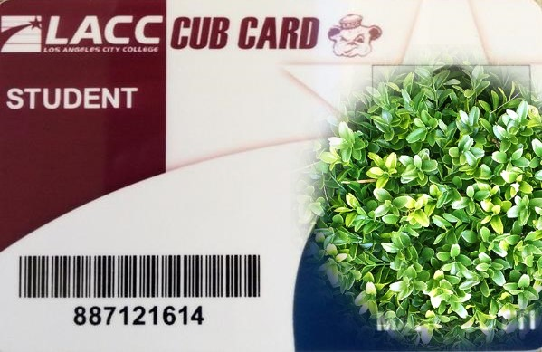

Your “blue” card is an important document.  
**Do Not Lose It!**   
You will need this card for the Testing Center.  
 You will need this card to get your LACC student ID Card.  
You will need this to use any LACC facilities.

**This card has your student ID number!**

This is your Student ID Number

LACC STUDENT ID CARD

**Student Benefits**

With your LACC student ID card – you can get:

* Discounts at movies
* Use the Library
* Use the computers at the Library
* Use the Campus Gym
* Use it as an ID card when you open your bank account or buy a cell phone
* Use it for discount fares on buses

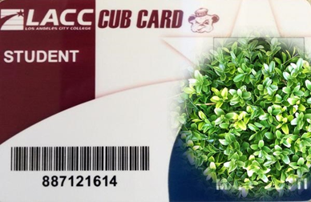

**Your Picture**Here!

**First, Last Name**

**Transfer to Los Angeles City College: ESL Requirements**

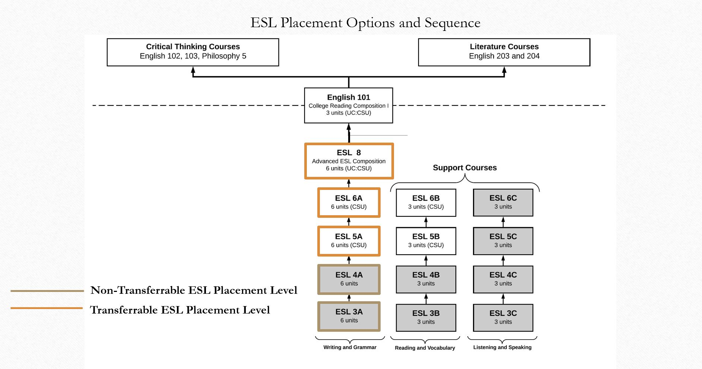

**Student Housing Information**

**Housing**

Los Angeles City College does not offer on-campus housing. To assist you in securing a place to stay while studying in Los Angeles, below are a few housing options and contact information. Please note that LACC provides general information regarding housing accommodations for the purpose of assisting students only. The college does not assume any responsibilities for the condition, suitability, or reliability of the resources listed below, nor does it assume accountability or liability for any agreement and contracts into which students enter with them.

**Homestay Option**

[**Student Room Stay**](https://go.studentroomstay.com/los-angeles-city-college)

[**Education Bridge**](https://residenceinusa.com/?lang=en) or Email, Mai Okumura, [**mai@los-info.com**](mailto:mai@los-info.com?subject=Future%20LACC%20Student%20Needing%20Housing)

[**Universal Student Housing**](https://www.ushstudent.com/homestay-prices-and-schools/southern-california/homestay-los-angeles-city-college) or Call, (001) **310-824-4908**

**Housing Assistance Agency**

If you would like assitance finding housing in Los Angeles whether it is shared housing, a room for rent, or your own home, use the link below to have an agency assist you with your housing search.

* [**Education Bridge**](https://www.los-info.com/en/homes)
* [**4Stay**](https://lacitycollege.4stay.com/)

**Shared Housing Options**

If you are looking for a shared housing option with private space that is fully furnished and has access to community spaces and activities, click on the link below:

* [**Eddy**](http://www.eddy.co/#experience)
* [**Starcity Co-Living**](https://starcity.com/communities/los-angeles)
* [**LA Student Dorms**](http://lastudentdorm.com/)
* [**SOTA (Koreatown Co-Living)**](https://gosota.com/koreatown)

**Private Apartment Living**

This housing option is popular for students who are independent and seek a space of their own. Most students choose this option after they have established connections in the area and have made friends during their first year. Most students rent an apartment for six-month to one-year periods of time.

When selecting your apartment, make sure it is in a desirable location and close to bus lines, shopping and social activities. Most students who choose this option will live with one or more roommates, but living alone is also an option for those who would like more personal space. Since choosing an apartment is such a personal decision, with so many options and possibilities to choose from, it is the students’ responsibility to make their own living arrangements.

**Housing Search Engines**

* [**https://affordablehousingonline.com/housing-search/California/Los-Angeles**](https://affordablehousingonline.com/housing-search/California/Los-Angeles) (this link also lists units that rent to voucher holders)
* [**https://www.lowincomehousing.us/CA/los_angeles.html**](https://www.lowincomehousing.us/CA/los_angeles.html)
* [**https://www.socialserve.com/index.html**](https://www.socialserve.com/index.html)
* [**https://www.solarentals.com/**](https://www.solarentals.com/)
* [**https://www.trulia.com/**](https://www.trulia.com/)
* [**https://hotpads.com/**](https://hotpads.com/)
* [**https://www.zillow.com/**](https://www.zillow.com/)
* [**Local Guide**](https://www.apartmentguide.com/apartments/California/Los-Angeles/#local)
* [**Rental Calculator**](https://www.apartmentguide.com/blog/how-much-rent-can-i-afford/)
* [**Apartment Guide**](https://www.apartmentguide.com/apartments/California/Los-Angeles/#local)

**Student Housing Information Continued**

**Emergency Rental Assistance Links:**

* [**https://hcidla.lacity.org/**](https://hcidla.lacity.org/)
* [**https://wwwa.lacda.org/programs/rent-relief**](https://wwwa.lacda.org/programs/rent-relief)
* [**http://www.longbeach.gov/lbds/lbcares/**](http://www.longbeach.gov/lbds/lbcares/)

**After Finding a Place to Live: Get Set Up with Internet and Other Home Services**

[**In My Area**](http://www.inmyarea.com/internet/california/los-angeles)**:** Find providers and compare prices for Internet, Cable TV and other home services available in your specific area. This service is at no cost to students and includes free relocation consultations.

**LACC DISCLAIMER**

**LACC offers these facilities as suggestions only and does not endorse, support or assume responsibility for these facilities. Beware of scams when searching for housing. Los Angeles is a large city – look for housing close to public transportation in safe neighborhoods. LACC accepts no responsibility for student housing/hotels and cannot be held responsible for students.**

**Communication with the Language Academy**

**IF THERE IS A PROBLEM - CALL THE HELP DESK AT (323) 953-4000 ext. 2455**

**Languages spoken: English, Spanish, Armenian, and Russian.**

**ZOOM ROOM: Click the link for ZOOM ROOM: M-TH: 9am-4pm & Friday 9am -12pm PST**

[**https://laccd.zoom.us/j/4606498846#success**](https://laccd.zoom.us/j/4606498846#success)

**Airport Pickup/Airport Transfer/Getting Around**

The closest airport to LACC Language Academy is LAX. Several pickup services are available to arrange rides to your housing. Coordinate with the shuttle services before you arrive. Taxis and buses are available at the airport. LAX is a very busy airport – plan your transportation ahead of landing at the airport.

**TRANSPORTATION / AIRPORT PICK-UP:** 1. Super Shuttle – 1-800-258-3826 / [www.supershuttle.com/htm/](http://www.supershuttle.com/htm/)  
 2. Prime Time Shuttle – 1-800-733-8267 / [www.primetimeshuttle.com/socal.htm](http://www.primetimeshuttle.com/socal.htm)  
 3. Xpress Shuttle – 1-800-427-7483 / [www.xpressshuttle.com/los_angeles.htm](http://www.xpressshuttle.com/los_angeles.htm)  
 4. LAX Transport 310-869-8906/ [www.laxtransport.com](http://www.laxtransport.com)

**LOCAL TRANSPORTATION:**

* Metro bus (MTA): 1-800-266-6883 or [www.metro.net](http://www.metro.net)

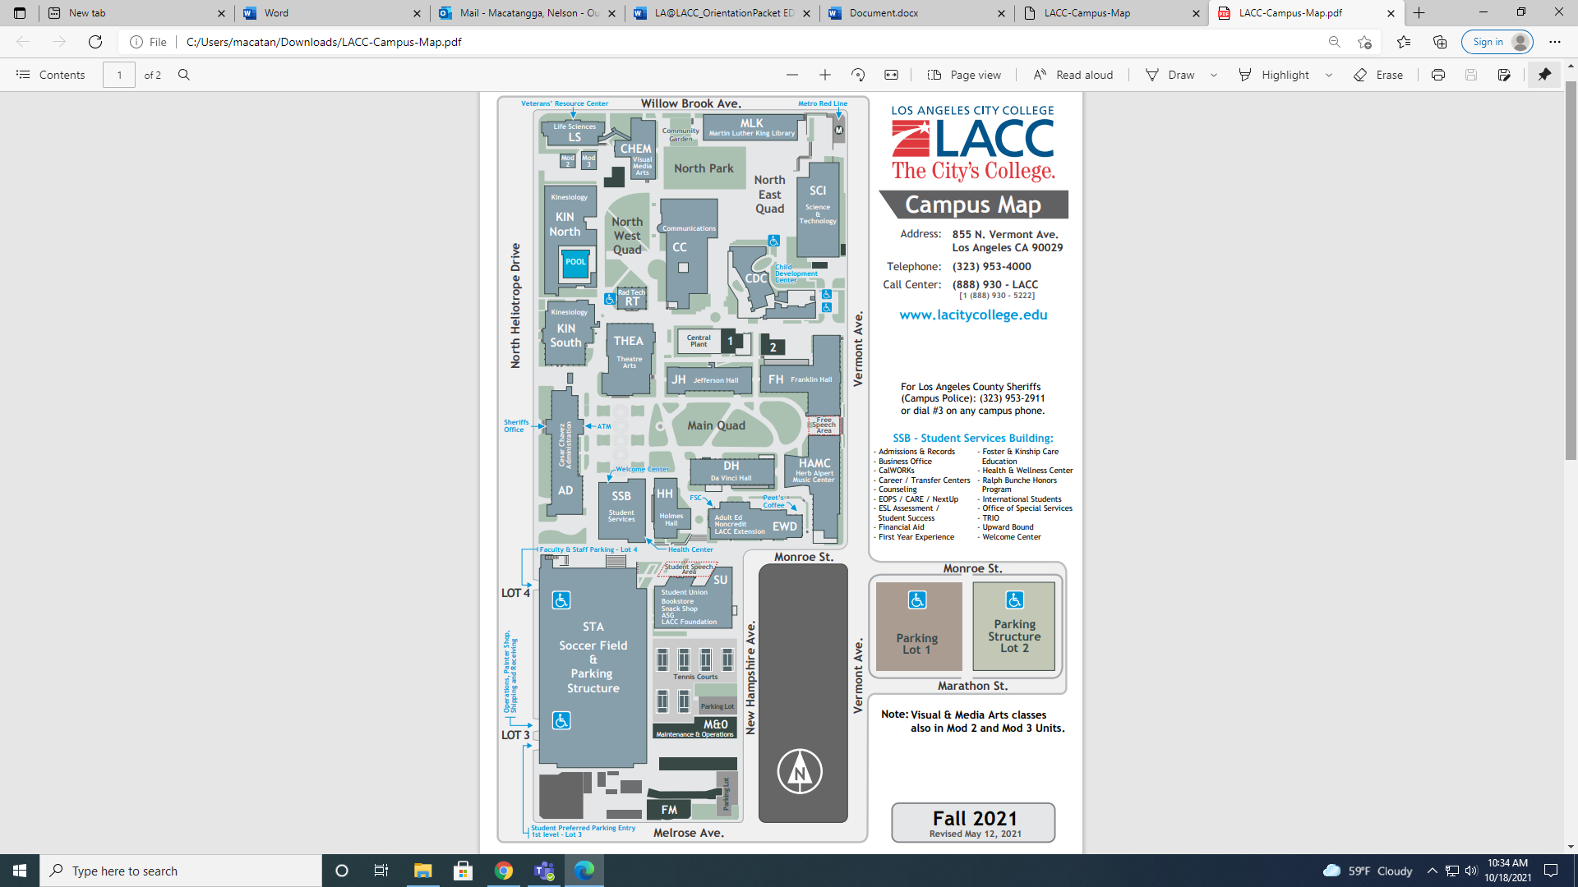

**Los Angeles City College/LACC Community Map**

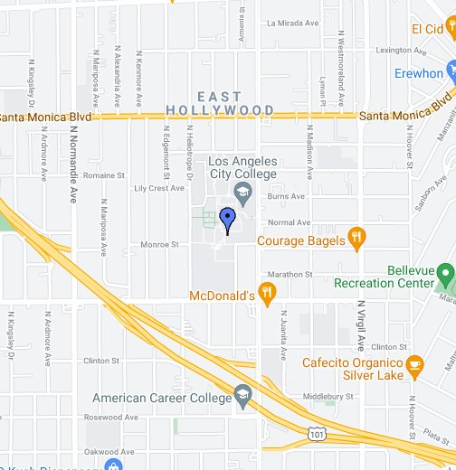

**Los Angeles City College/Los Angeles Map**

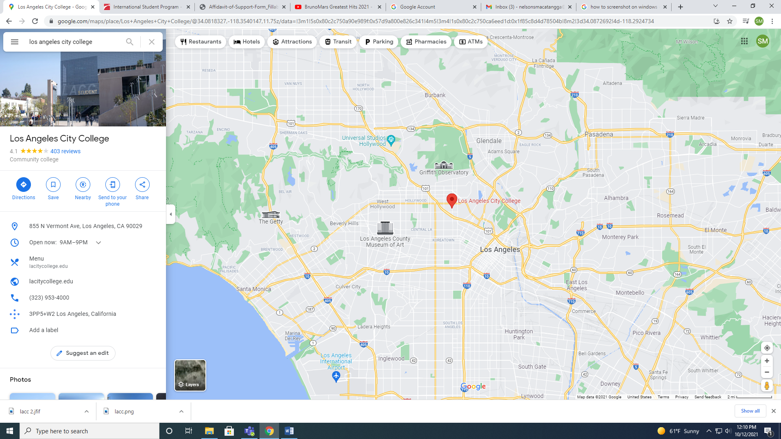

**SUCCESSFUL COLLEGE STUDENTS**



Successful students accept personal responsibility

Successful students are self-motivated

Successful students know how to manage their time

Successful students make friends

Successful students enjoy learning

Successful students develop emotional intelligence

Successful students believe in themselves

**Ideas to stay healthy and happy**:

Get plenty of rest and eat good food

Talk to your classmates (make friends)

E-mail or text your family, your friends

Be on time to class and do your homework!

HAVE FUN!

**Banking in the United States**

With a bank account, you can pay all of your bills by check, and manage your bill payments online. In addition, many banks issue debit cards with a MasterCard or Visa emblem, which enables you to use the card to make purchases anywhere that accepts credit cards.

## **Types of Accounts**

There are several different types of bank accounts. The two most common are checking accounts and savings accounts.

**Checking accounts**

Checking accounts are probably what you, as an international student, will need. They allow you to deposit and withdraw money frequently. When you open a checking account, you usually get a checkbook and a bankcard, which you can use to make purchases and pay bills. Often these accounts have minimum monthly balances and service fees, and these vary according to the type of account you have.

**Savings accounts**

Savings accounts are for long-term deposits for earning interest. Interest rates, minimum balances, and service fees for savings accounts vary from bank to bank, and depend on the amount of money deposited. You will probably not need a savings account as an international

## **How to Open a Bank Account**

As an international student, you must go into the bank to open an account. When you go to the bank to open a bank account, you will need to bring:

* Your full name, home address, home telephone number, your campus telephone number, and your college address (Letterhead showing the local address – i.e. utility bills or apartment contract)
* Unexpired passport
* I-94 card
* I-20
* Any secondary form of identification (such as: your passport, your Student ID card, birth certificate, state driver’s license, or a letter from the International Students and Scholars Office)
* Proof of enrollment verification letter from your school (your acceptance letter will work)
* You will also need the funds you want to deposit and open the account with. Every bank has slightly different requirements, so make sure you ask beforehand so you do not forget something you need.

**LIST OF ACADEMIC PROGRAMS AT LOS ANGELES CITY COLLEGE**

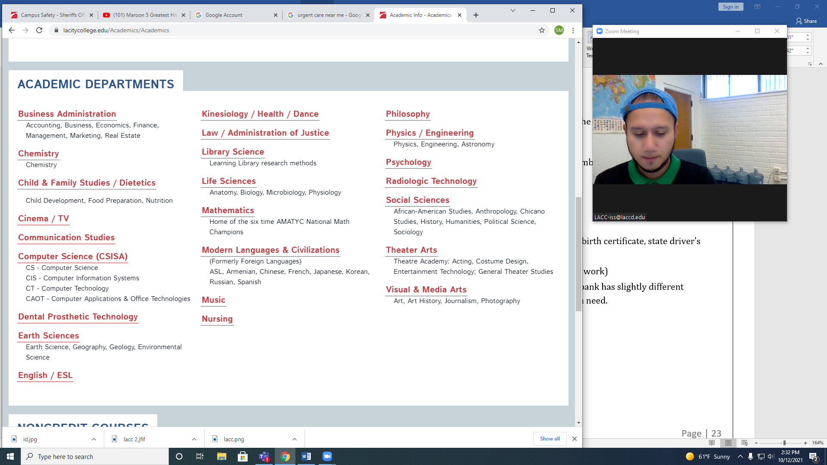

Los Angeles City College  
 Language Academy

**LACC Language Academy Office Information**   
Tel: 323 953 4000 ext. 2470  
Fax: 323 953 4013

<https://www.lacitycollege.edu/Resources/International-Students/Language-Academy>

**LACC Office Hours:**   
Monday - Thursday: 9:00am – 4:00pm  
Friday: 9:00am-12:00pn

**LACC Office Staff:**   
Mr. Darren Grosch  
Associate Dean, Academic Affairs   
Email: [groschda@lacitycollege.edu](mailto:groschda@lacitycollege.edu)   
  
George Agoian  
DSO, Community Presenter  
Email: [agoiang@lacitycollege.edu](mailto:agoiang@lacitycollege.edu)

Elonda Austin Pope

Office Assistant

Email: [AUSTINE@LACITYCOLLEGE.EDU](mailto:AUSTINE@LACITYCOLLEGE.EDU)

**LACC Instructors:**

Ms. Alla Bokhman Ms. Haira Chang Ms. Kenya Ganda Ms. Michelle O’Hair Mr. Joshua Steward

**Directions to LACC Office:**   
The LACC office is located in the International Student Program office, Cesar Chavez, Admin Services: 1st Floor, 109

855 N. Heliotrope Avenue, Los Angeles, CA 90029

*The Los Angeles City College is committed to providing equal opportunity in which no person is subjected to discrimination based on ethnic group identification, national origin, religion, age, sex, race, color, ancestry, sexual orientation, physical or mental disability, or retaliation.*